**Supporting Information**

**Traffic volume and long-distance foraging movements to migratory prey shape roadkill patterns in Serengeti spotted hyenas**

Marwan Naciri1,2,*, Aimara Planillo1,Morgane Gicquel1,3, Marion L. East1, Heribert Hofer3,4,5 Sonja Metzger1, Sarah Benhaiem1

1 Department of Ecological Dynamics, Leibniz Institute for Zoo and Wildlife Research, Alfred-Kowalke-Strasse 17, D-10315 Berlin, Germany

2 Master de Biologie, Ecole Normale Supérieure de Lyon, Université Claude Bernard Lyon I, Université de Lyon, 69342 Lyon Cedex 07, France

3 Department of Biology, Chemistry, Pharmacy, Freie Universität Berlin, Berlin, Germany

4 Leibniz Institute for Zoo and Wildlife Research, Alfred-Kowalke-Strasse 17, D-10315 Berlin, Germany

5 Department of Veterinary Medicine, Freie Universität Berlin, Berlin, Germany

* Corresponding author: marwan.naciri@ens-lyon.fr

**Contents**

**1. Commuting movements and roadkill risk, p2**

**2. Distribution of research effort across seasons, p4**

**3. References to supporting information, p5**

1. **Commuting movements and roadkill risk**

As Table S1 demonstrates, most carcasses were found when low prey abundance was scored in the respective clan territory (for details see (Hofer and East, 1993a)). During low prey abundance, adult and subadult clan members commute to feed on migratory herds (Hofer and East, 1993a, 1993b, 1993c, 2003). The three carcasses killed when prey abundance in their clan territory was scored medium belonged to an age class which also commutes at medium prey abundance (Hofer and East, 2003).

**Table S1. Roadkills of hyenas belonging to the study clans.** The values in the last three columns are evaluated for the time of death of each hyena. Prey abundance was assessed inside the territory of the clan to which each hyena belonged.

|  |  |  |  |  |  |  |  |  |
| --- | --- | --- | --- | --- | --- | --- | --- | --- |
| ID | Clan | Sex | Age class | Standardized rank | Distance from communal den when killed (km) | >4.2km from communal den | Prey abundance in clan territory | Likely roadkilled during commuting |
| hy_048 | Isiaka | F | cub | -0.29 | 6.8 | yes | low | NA |
| hy_071 | Isiaka | F | subadult | -0.14 | 10.4 | yes | medium | Yes |
| hy_061 | Pool | F | adult | 0.13 | 15.5 | yes | low | Yes |
| hy_052 | Isiaka | F | adult | 0.26 | 16.8 | yes | low | Yes |
| hy_047 | Pool | F | adult | 0.38 | 4.4 | yes | low | Yes |
| hy_084 | Isiaka | F | adult | 0.42 | 0.8 | no | low | No |
| hy_083 | Isiaka | F | adult | 0.47 | 0.8 | no | low | No |
| hy_056 | Mamba | F | adult | 0.7 | 30.2 | yes | low | Yes |
| hy_080 | Pool | F | adult | 1 | 10.7 | yes | low | Yes |
| hy_032 | Mamba | M | adult | NA | 4.4 | yes | medium | Yes |
| hy_059 | Pool | M | adult | NA | 4.2 | no | low | No |
| hy_063 | Mamba | M | adult | NA | 8.1 | yes | medium | Yes |
| hy_068 | Mamba | M | adult | NA | 7.7 | yes | NA | NA |

1. **Distribution of research effort across seasons**

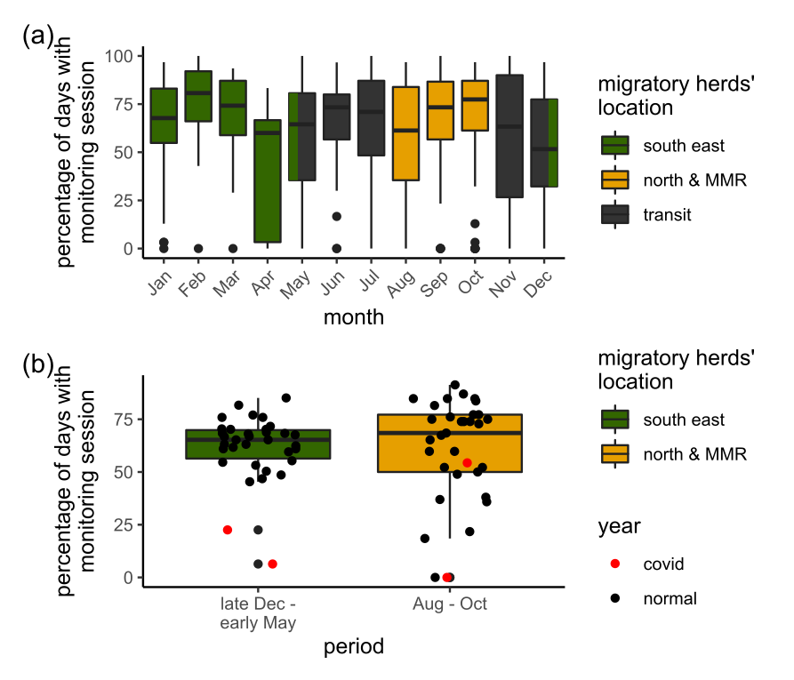We used records of monitoring sessions from our three study clans in the center of the Serengeti National Park to track researchers’ presence in the field and thus assess whether research effort varied across seasons. The proportion of days during which a monitoring session occurred was roughly the same over the years and over months, with some lows in April, Novmber and December (Fig. S1a). When considering the two periods defined by the location of the migratory herds, monitoring sessions were homogeneously distributed over the two periods (two-sample Wilcoxon test, n = 67, W = 618, p = 0.48, Fig. S1b).

**Figure S1. Research effort between 1989 and early 2022. (a)** Percentage of days of each month during which a monitoring session occurred, for each year between 1989 and early 2022. **(b)** Percentage of days of each season (as defined by the location of the migratory herds) during which a monitoring session occurred, for each year between 1989 and early 2022. Migratory herds are located in the southeast during the wet season (dark green) and in the north and Maasai Mara National Reserve (MMR) during the dry season (yellow) (Hopcraft et al., 2015). Years 2020 and 2021 during which the covid-19 pandemic altered monitoring efforts are indicated in red.

1. **References**

Hofer, H., and East, M.L. (1993a). The commuting system of Serengeti spotted hyaenas: how a predator copes with migratory prey. I. Social organization. Animal Behaviour *46*, 547–557. https://doi.org/10.1006/anbe.1993.1222.

Hofer, H., and East, M.L. (1993b). The commuting system of Serengeti spotted hyaenas: how a predator copes with migratory prey. II. Intrusion pressure and commuters’ space use. Animal Behaviour *46*, 559–574. https://doi.org/10.1006/anbe.1993.1223.

Hofer, H., and East, M.L. (1993c). The commuting system of Serengeti spotted hyaenas: how a predator copes with migratory prey. III. Attendance and maternal care. Animal Behaviour *46*, 575–589. https://doi.org/10.1006/anbe.1993.1224.

Hofer, H., and East, M.L. (2003). Behavioral processes and costs of co-existence in female spotted hyenas: a life history perspective. Evolutionary Ecology *17*, 315–331. https://doi.org/10.1023/A:1027352517231.

Hopcraft, J.G.C., Holdo, R.M., Mwangomo, E., Mduma, S., Thirgood, S.J., Borner, M., Fryxell, J.M., Olff, H., and Sinclair, A.R.E. (2015). Why are wildebeest the most abundant herbivore in the Serengeti? In Serengeti IV: Sustaining Biodiversity in a Coupled Human-Natural System, A.R.E. Sinclair, K.L. Metzger, S.A.R. Mduma, and J.M. Fryxell, eds. (Chicago: University of Chicago Press), p. 125.